# Spring Data Retake Exam

# SoftWeather Forecast

Accurate weekend SoftWeather Forecasts for hundreds of places around the World. We provide detailed Weather Forecasts over a 3 day period updated four times a day. Our interactive weather maps can be customized to show forecasts of temperature, sunrise and sunset. The software of Weather Forecasts has crashed and the owner has turned to SoftUni for help. Now a small team led by you must take on this task and make the SoftWeather Forecast. To offer a better experience to its customers, the SoftWeather team urgently needs a good enough application that collects all the information about all weather forecasts and can, with one click, dig through the sorted best locations for the weekend.

## Functionality Overview

The application should be able to easily **import** hard-formatted data and **support functionalities** for also **exporting** the imported data. The application is called – **SoftWeather Forecast**.

Look at the pictures below to see what must happen:

* The home page before importing anything:

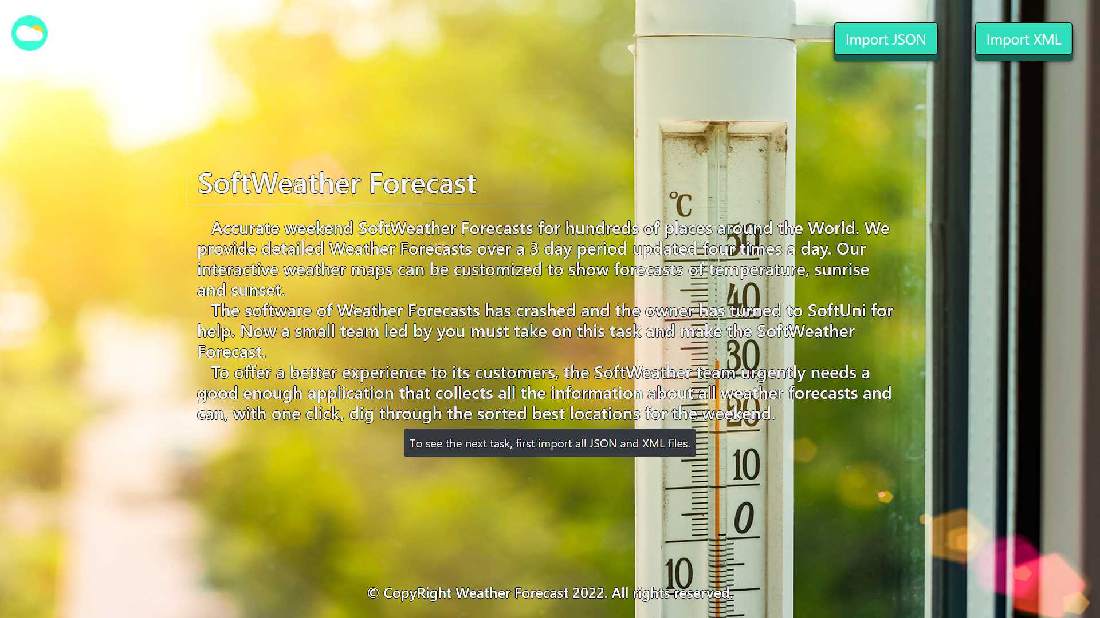

* The import JSON page before importing anything:

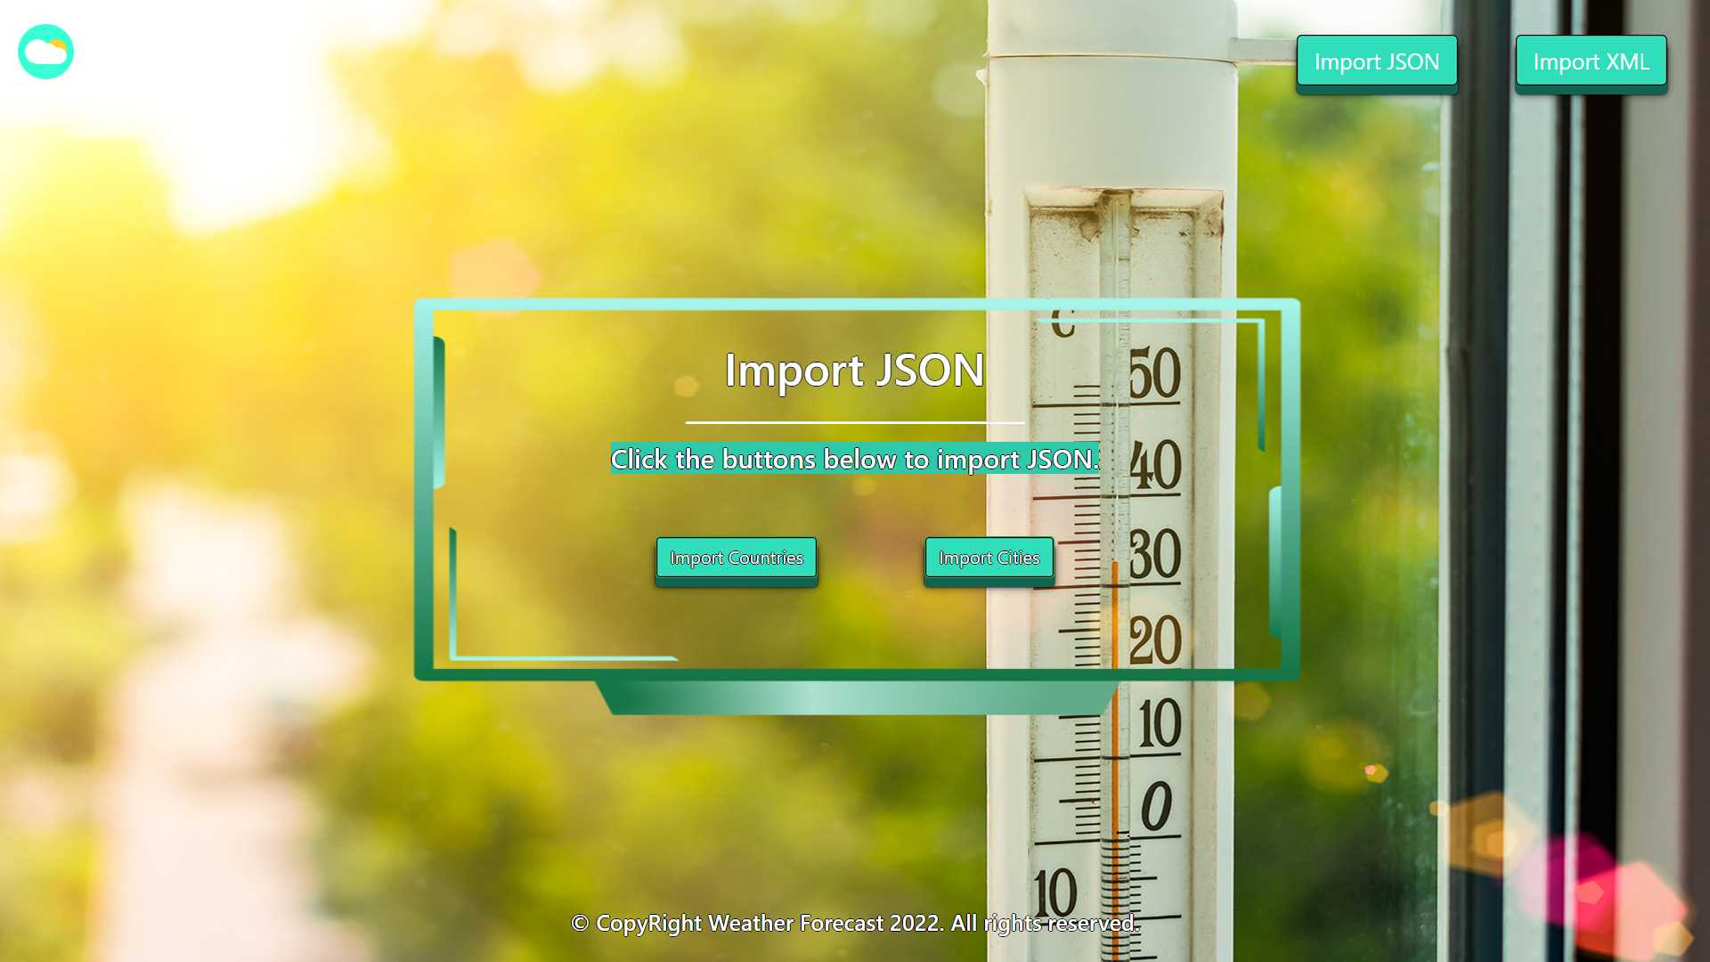

* Import the countries first:

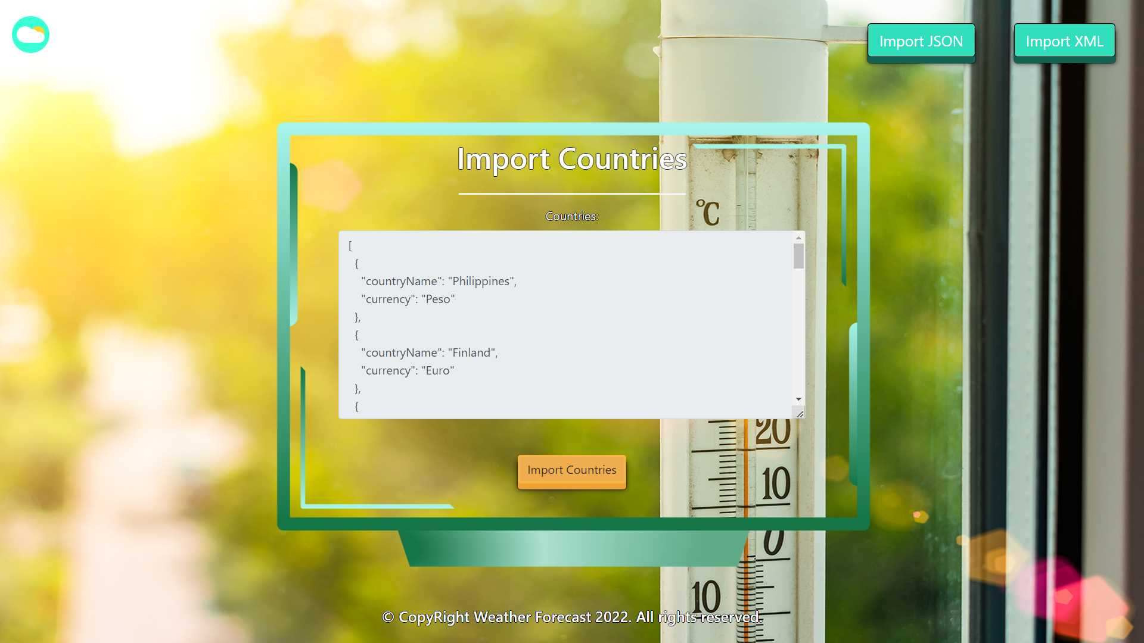

* Import the cities second:

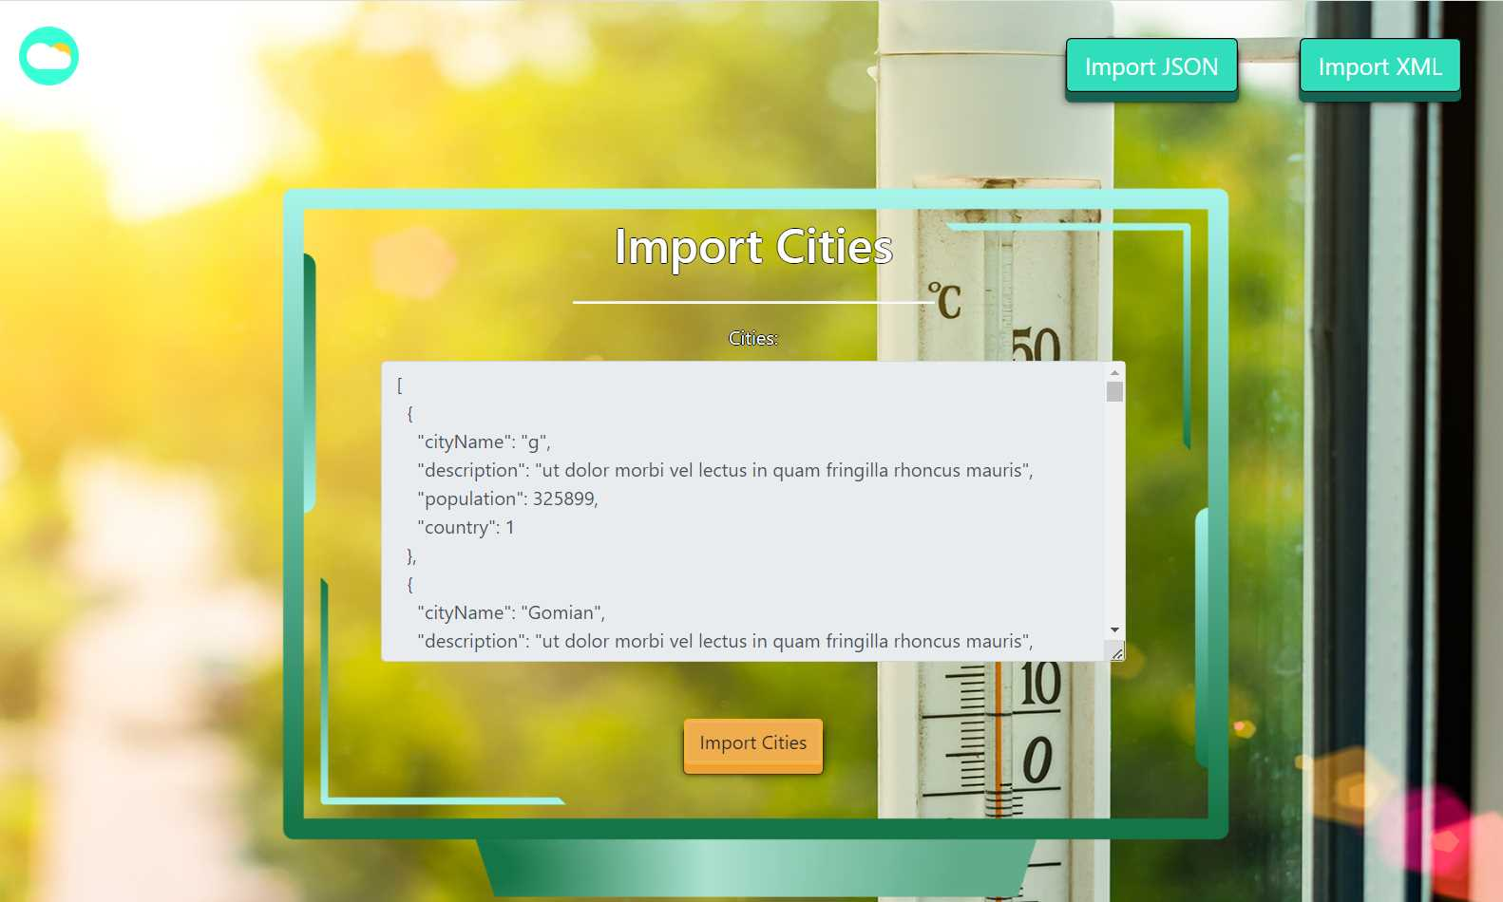

* The import JSON page after importing both files:



* The import XML page before importing the given data:

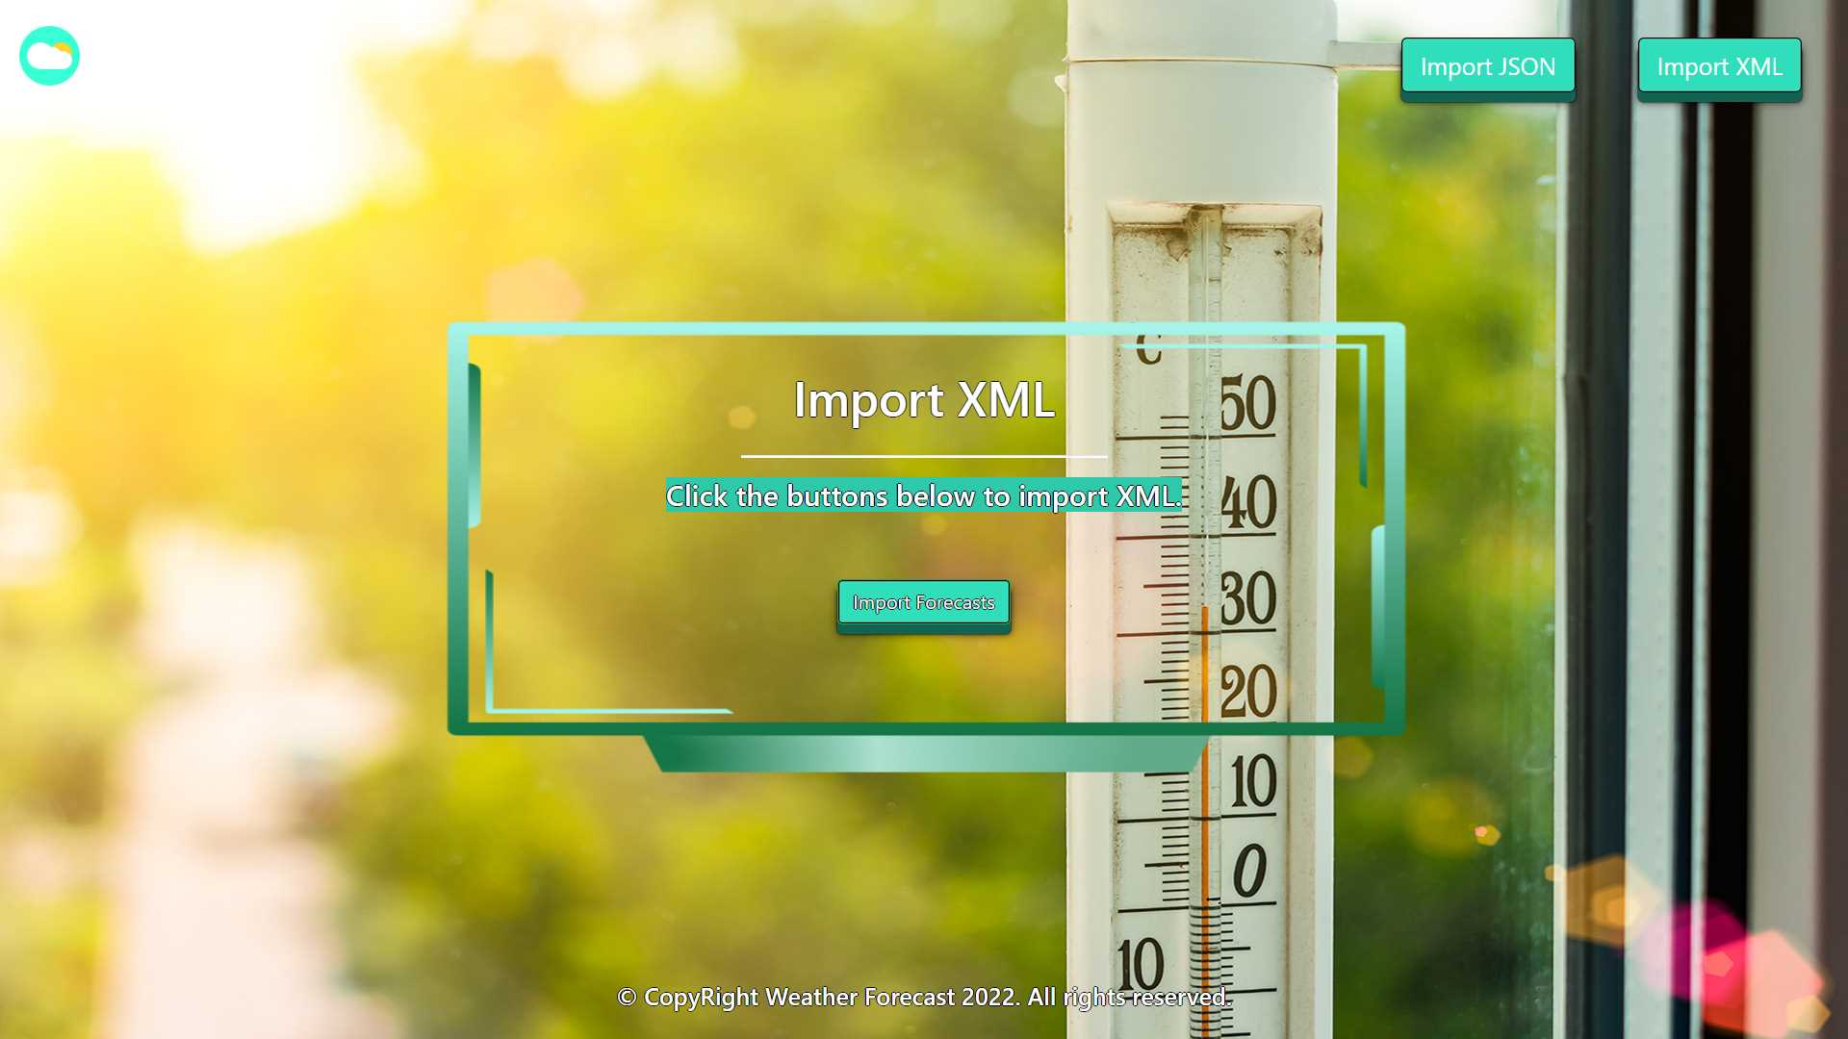

* Import the forecasts data:

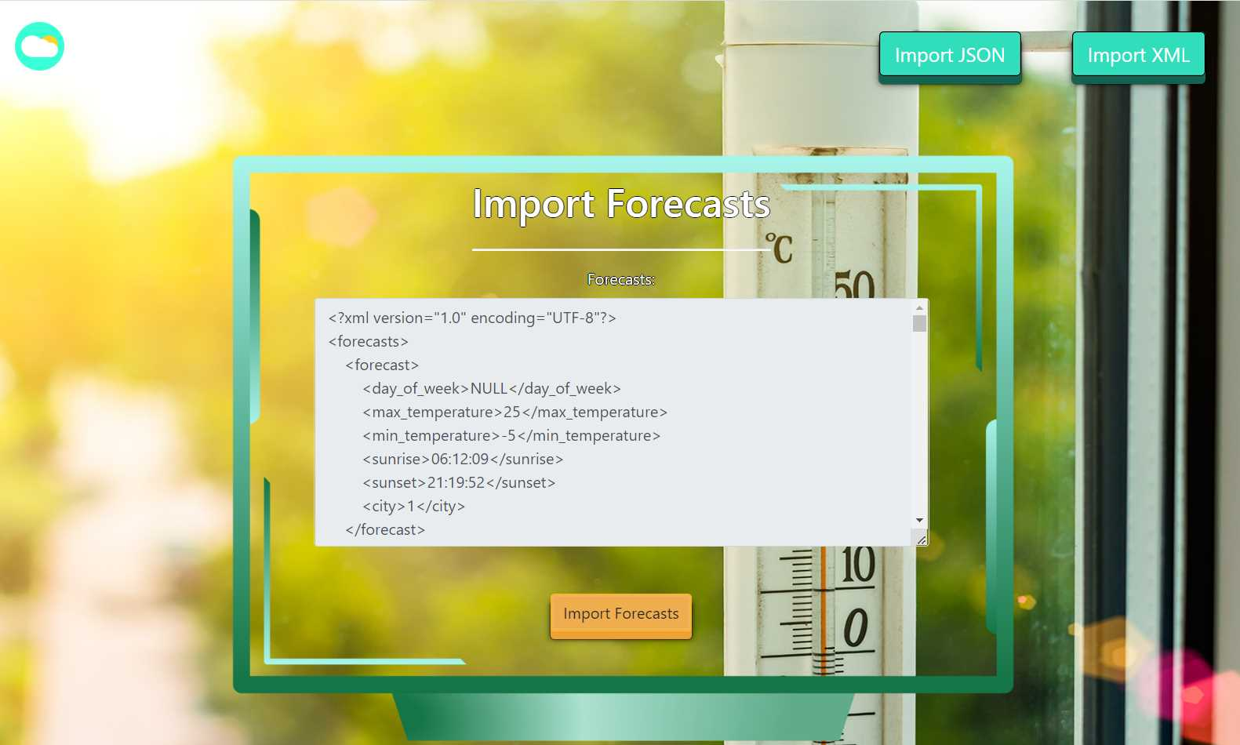

* The import XML page after importing the data:

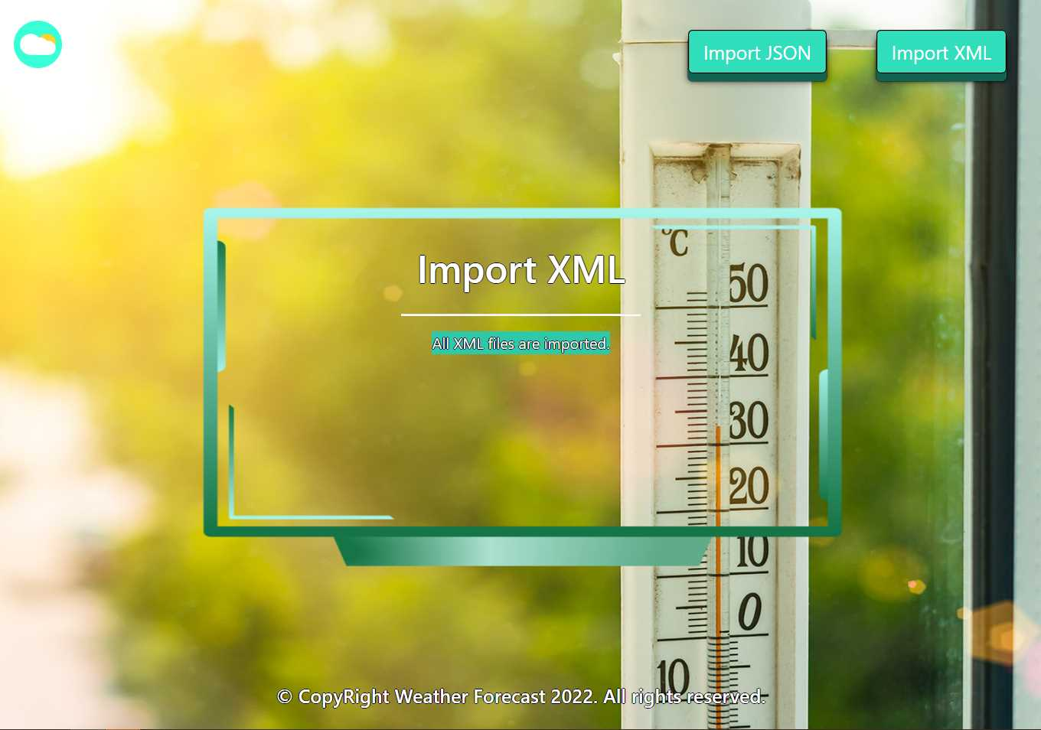

* The home page after the data is imported:

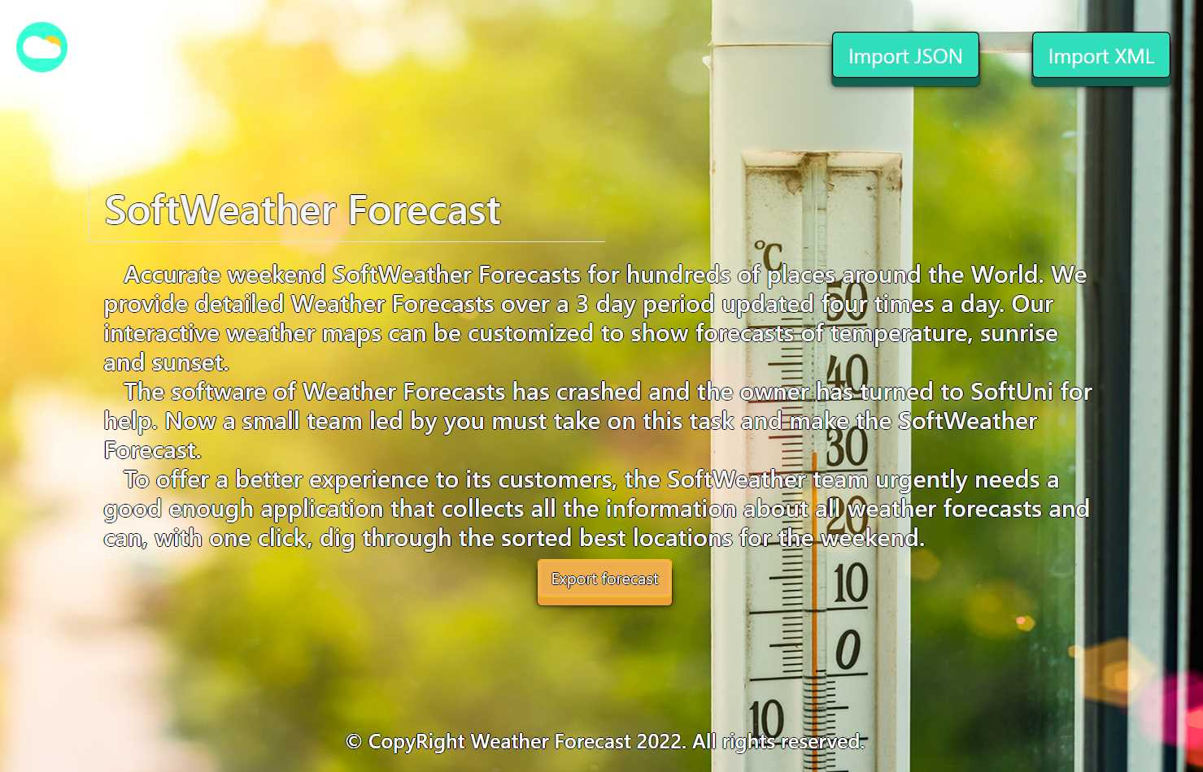

* Export Sunday forecasts where city population is less than 150000 ordered by max temperature in descending and then by forecast id in asc:

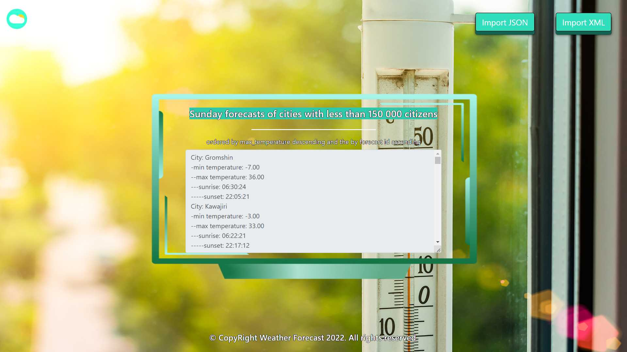

## Project Skeleton Overview

You will be given a **skeleton**, containing a **certain architecture (MVC)** with **several classes**, some of which are completely empty. The **Skeleton** will include the **files** with which you will **seed** the **database**.

## Model Definition

There are 3 main models that the **SoftWeather Forecast database** application should contain in its functionality.

Design them in the **most appropriate** way, considering the following **data constraints**:

### Country

* id – accepts **integer** values, a **primary identification field, an auto incremented field**.
* country name – accepts **char sequence** (between 2 to 60 inclusive). The values are **unique in the database**. **Cannot** be **null**.
* currency – accepts **char sequences** (between 2 and 20 inclusive). **Cannot** be **null**.

### City

* id – accepts **integer** values, a **primary identification field, an auto incremented field**.
* city name – a **char sequence** (between 2 to 60 inclusive). The values are **unique in the database**. **Cannot** be **null**.
* description – accepts very long **char sequence** (min 2 symbols).
* population – accepts **number** values that are **more** than or **equal** to **500**. **Cannot** be **null**.
* **Constraint**: The cities table has а relation with the countries table.

### Forecast

* id – accepts **integer** values, a **primary identification field, an auto incremented field**.
* day of week – **enumerated** value, one of the following – **FRIDAY, SATURDAY, SUNDAY**. **Cannot** be **null**.
* max temperature – a **floating point number**. Must be between **-20** and **60** (both numbers are **INCLUSIVE**)**.** **Cannot** be **null**.
* min temperature – a **floating point number**. Must be between **-50** and **40** (both numbers are **INCLUSIVE**). **Cannot** be **null**.
* sunrise – time of the sunrise. **Cannot** be **null**.
* sunset – time of the sunset. **Cannot** be **null**.
* **Constraint**: The forecasts table has а relation with the cities table.

### Relationships

Your partners gave you a little hint about the more complex relationships in the database so that you can implement it correctly.

One **Country** may have many **Cities**, but one **City** may have only one **Country**.

One **Forecast** may have only one **City**, but one **City** may have many **Forecasts**.

### Constraint

* Name the entities and their class members **exactly** in the **format stated** above.
* All fields are **nullable** unless explicitly stated to be **NOT NULL**.

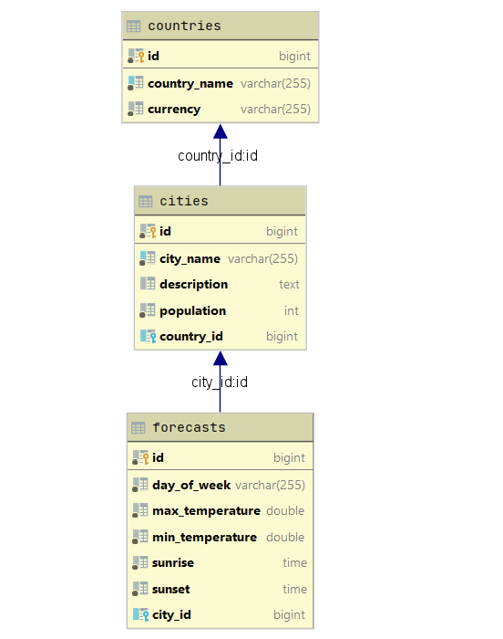

## Data Import

Use the provided files to populate the database with data. Import all the information from those files into the database.

**You are not allowed to modify the provided files.**

**ANY INCORRECT** data should be **ignored** and a message:

"**Invalid {country / city / forecast}**" should be printed.

**When the import is finished:**

"**Successfully imported {country / city / forecast} {country – currency / city name - population / day of week – max temperature}**"

### JSON Import

Your new colleagues have prepared some JSON data for you to import.

|  |
| --- |
| **Countries (countries.json)** |
| [  {  "countryName": "Philippines",  "currency": "Peso"  },  {  "countryName": "Finland",  "currency": "Euro"  },  {  "countryName": "X",  "currency": "Euro"  },  {  "countryName": "Turkey",  "currency": "T"  },  {  "countryName": "Sweden",  "currency": "Krona"  },  {  "countryName": "China",  "currency": "Yuan Renmbinbi"  },  ... |
| Successfully imported country Philippines - Peso  Successfully imported country Finland - Euro  Invalid country  Invalid country  Successfully imported country Sweden - Krona  Successfully imported country China - Yuan Renmbinbi  Invalid country  … |

#### Constraint

* **If the city name already exists in the DB return "Invalid city".**

|  |
| --- |
| **Cities (cities.json)** |
| [  {  "cityName": "g",  "description": "ut dolor morbi vel lectus in quam fringilla rhoncus mauris",  "population": 325899,  "country": 1  },  {  "cityName": "Gomian",  "description": "ut dolor morbi vel lectus in quam fringilla rhoncus mauris",  "population": 325899,  "country": 1  },  {  "cityName": "Gomian",  "description": "ut dolor morbi vel lectus in quam fringilla rhoncus mauris",  "population": 325899,  "country": 1  },  {  "cityName": "Dibeet",  "description": "ligula nec sem duis aliquam convallis nunc proin at turpis a pede posuere nonummy integer non",  "population": 300378,  "country": 1  },  {  "cityName": "Mordor",  "description": "u",  "population": 325899,  "country": 1  },  {  "cityName": "Cagtotolo",  "description": "vitae nisi nam ultrices libero non mattis pulvinar nulla pede ullamcorper augue a suscipit",  "population": 276813,  "country": 1  },  . . . |
| Invalid city  Successfully imported city Gomian - 325899  Invalid city  Successfully imported city Dibeet - 300378  Invalid city  Successfully imported city Cagtotolo - 276813  Invalid city  … |

### XML Import

Your new colleagues have prepared some XML data for you to import.

**Constraint:**

* **If the forecasts for the same day of week of the city already exist in the DB return "Invalid forecast".**

|  |
| --- |
| **Forecasts (forecasts.xml)** |
| *<?*xml version="1.0" encoding="UTF-8"*?>* <forecasts>  <forecast>  <day_of_week>NULL</day_of_week>  <max_temperature>25</max_temperature>  <min_temperature>-5</min_temperature>  <sunrise>06:12:09</sunrise>  <sunset>21:19:52</sunset>  <city>1</city>  </forecast>  <forecast>  <day_of_week>FRIDAY</day_of_week>  <max_temperature>25</max_temperature>  <min_temperature>-5</min_temperature>  <sunrise>06:12:09</sunrise>  <sunset>21:19:52</sunset>  <city>1</city>  </forecast>  <forecast>  <day_of_week>FRIDAY</day_of_week>  <max_temperature>15</max_temperature>  <min_temperature>-5</min_temperature>  <sunrise>06:13:02</sunrise>  <sunset>21:19:32</sunset>  <city>1</city>  </forecast>  <forecast>  <day_of_week>FRIDAY</day_of_week>  <max_temperature>61</max_temperature>  <min_temperature>-5</min_temperature>  <sunrise>06:12:09</sunrise>  <sunset>21:19:52</sunset>  <city>1</city>  </forecast>  <forecast>  <day_of_week>FRIDAY</day_of_week>  <max_temperature>25</max_temperature>  <min_temperature>-51</min_temperature>  <sunrise>06:12:09</sunrise>  <sunset>21:19:52</sunset>  <city>1</city>  </forecast> ... |
| Invalid forecast  Successfully import forecast FRIDAY - 25.00  Invalid forecast  Invalid forecast  Invalid forecast  Successfully import forecast FRIDAY - 13.00  Invalid forecast  Invalid forecast  Successfully import forecast FRIDAY - 25.00 ... |

## Data Export

Get ready to export the data you have imported in the previous task. Here you will have some complex database querying. Export the data in the formats specified below.

### Export Sunday forecast from Database

* Extract from the database, the **city name, min temperature (to the second digit after decimal point), max temperature (to the second digit after the decimal point), sunrise** and **sunset** of the **forecast**.
* **Filter only forecasts from sunday and from cities with less than 150000 citizens, order them by max temperature in descending order, then by the forecast id in ascending order.**
* Return the information in this format:
* **"City: {cityName}:**

**-min temperature: {minTemperature}**

**--max temperature: {maxTemperature}**

**---sunrise: {sunrise}**

**----sunset: {sunset}**

**. . . "**

